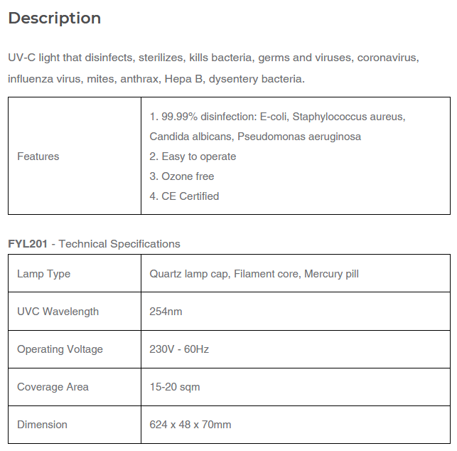

**Disinfection distance**

According to felcostore (2022), the Firefly Yellow Shield Antivirus & Germicidal UV Tube Set has a coverage area of 15-20 sqm. Using the beam angle formula, we can calculate the beam angle to determine the diameter of the object or the effective illuminated surface.

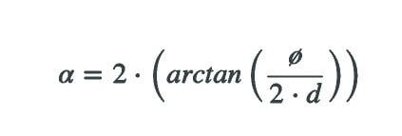

Where:

* α: Beam angle
* Ø: Diameter of the object or surface to be illuminated
* d: Distance between lamp and object or surface
* arctan: Inverse function of the tangent for angle calculation

substituting the values we have, we get:

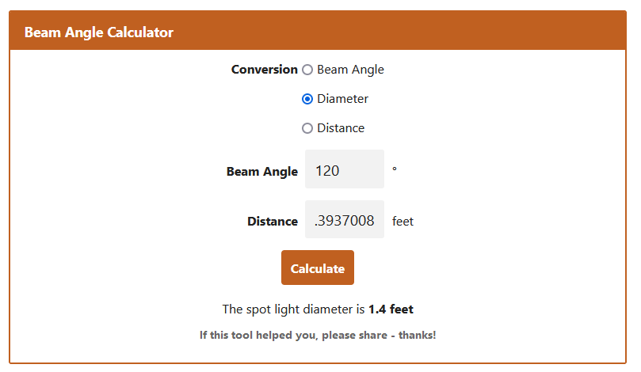

The effective spot light diameter of the automatic disinfection box is 1.4 feet. By reducing the distance of the illuminated object from the lamp, the illuminated object remains inside the 100% intensity area.

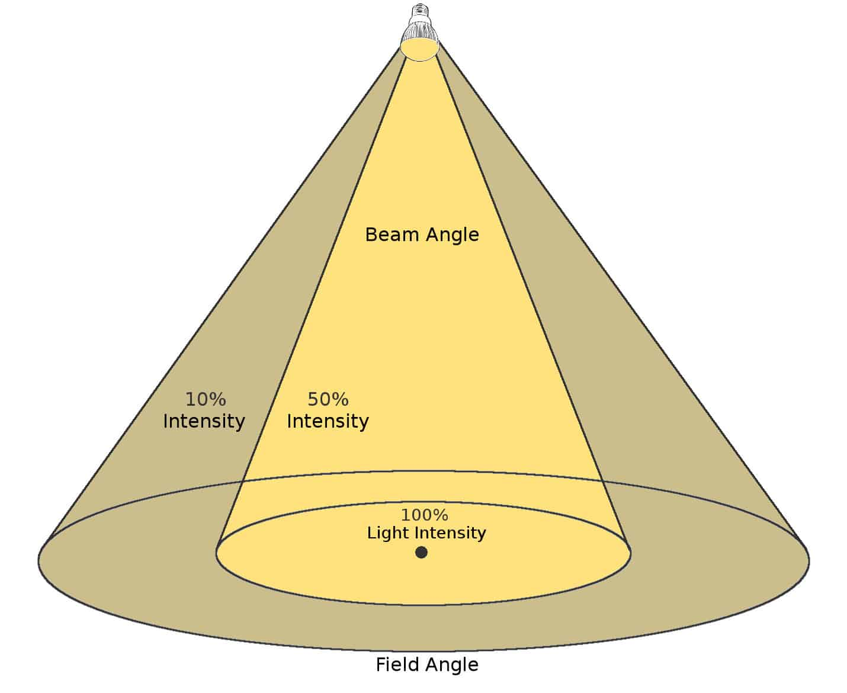

Figure 1: figure from lampphq

Following considerations for a beam angle, the beam angle of 120 degrees has a very good diffusion of light for bright whole room spotlight lighting (aisled, 2022).

**What is beam angle?**

According to lampphq (2022), the beam angle determines the diameter of the generated light circle on the illuminated surface or object. The ideal beam angle usually depends very individually on the place of use of the lamp and on your own use-case. This can be determined very well with the beam angle calculator.

Essentially, large beam angles of 90° or 120° are well suited for illuminating a room over a large area. Small beam angles of 15° to 35° are a good choice for decorative lighting.

**UVC exposure (direct exposure)**

According to the U.S Food & Drug Administration (2022), there are also limitations to how effective UVC radiation can be at inactivating viruses, generally.

UVC radiation can only inactivate a virus if the virus is directly exposed to the radiation. Therefore, the inactivation of viruses on surfaces may not be effective due to blocking of the UV radiation by soil, such as dust, or other contaminants such as bodily fluids. Many of the UVC lamps sold for home use are of low dose, so it may take longer exposure to a given surface area to potentially provide effective inactivation of a bacteria or virus.

UVC radiation is commonly used inside air ducts to disinfect the air. This is the safest way to employ UVC radiation because direct UVC exposure to human skin or eyes may cause injuries, and installation of UVC within an air duct is less likely to cause exposure to skin and eyes.

There have been reports of skin and eye burns resulting from improper installation of UVC lamps in rooms that humans can occupy.

**Time to Inactivate Microorganisms**

According to the Americanultraviolet (2022), the effectiveness of UVC light is based on the variables of time or the length of exposure, intensity of the source, and the distance or how far the source is from the target. Different microorganisms require various levels of UVC for inactivation and it rest on how the bacterial cell is built.

**UV-C Penetrable Plastic & Materials**

According to Kosta G. (2020), short wave UV (UVC) cannot pass through most plastics or ordinary glass. Most acrylic plastics do not allow UV-C wavelengths (100-280 nm) to penetrate. Also, very thin acrylic sheets of below 5 millimeters do not let UVC light penetrate.

In addition, suitable transparent media do not exist anymore, limiting the choices to reflective optics such as Highly purified calcium fluoride(CaF2), Magnesium Fluoride (MgF2), Lithium Fluoride (LiF). UV-grade fused silica, Artificial diamond and Borate crystals.

**UV-C exposure risks**

According to the FDA (2022), UVC radiation can cause severe burns of the skin and eye injuries (photokeratitis). Skin burns and eye injuries from UVC exposure usually resolve within a week with no known long-term damage. Since the penetration depth of UVC radiation is very low, the risk of skin cancer, cataracts or permanent vision loss is also thought to be very low. The type of eye injury associated with exposure to UVC causes severe pain and a feeling of having sand in the eyes. Sometimes people are unable to use their eyes for one to two days. It can occur after a very short exposure (seconds to minutes) to UVC radiation.

**Risks associated with using some UVC lamps**

According to the FDA (2022), some UVC lamps emit small amounts of UVB radiation. Therefore, exposure to a high dose or prolonged low dose of radiation from some UVC lamps can potentially contribute to effects like cataracts or skin cancer that are caused by cumulative exposure to UVB radiation.

Additionally, some UVC lamps generate ozone which could cause irritation to breathing passages (that is nose, throat, and lungs), particularly for those who have respiratory sensitivity such as asthma or allergies. Exposure to high levels of ozone gas may also worsen chronic respiratory diseases, such as asthma, or increase vulnerability to respiratory infection.

**Effect of UV radiation on human body**

According to the FDA (2020), UVA and UVB rays can cause damage to the skin. Sunburn is a sign of short-term overexposure, while premature aging and skin cancer are side effects of prolonged UV exposure.

**How hot do the lamps get?**

According to the Americanultraviolet (2022), Germicidal UVC lamps do not produce much heat and about the same as fluorescent lamps. fluorescent lamps don’t use resistance to emit light, they emit about 75% less heat than an incandescent bulb. As a result, they save energy and keep whatever room they’re in at a cooler temperature.

**UV-C effective distance**

according to felcostore.ph (2022), the Firefly Yellow Shield Antivirus & Germicidal UV have a coverage area of 15 to 20 sqm.

**UV-C dosage**

Dahil walang uvc detector, gagawin naten ang experiment.

Sources:

<https://www.felcostore.ph/products/firefly-yellow-shield-antivirus-germicidal-uv-tube-set?variant=42080995639460>

<https://lamphq.com/beam-angle/>

<https://www.aisledlight.com/choose-right-beam-angle-led-lights/>

<https://www.fda.gov/medical-devices/coronavirus-covid-19-and-medical-devices/uv-lights-and-lamps-ultraviolet-c-radiation-disinfection-and-coronavirus>

<https://www.americanultraviolet.com/germicidal-healthcare-solutions/frequently-asked-questions-about-UVC.html>

<https://start.askwonder.com/insights/uv-c-penetrable-plastic-and-materials-2-5li2z1mx1>

https://www.fda.gov/radiation-emitting-products/tanning/ultraviolet-uv-radiation